**Simulation of Motor:**

To get the characteristics of a permanent magnet DC motor we used MATLAB and Simulink to design a mathematical model of motor and display Speed and Torque characteristics.

The equations involved in building a mathematical model are:

Va=iaRa+La(dia/dt)+Eb

Eb=(KePhi)Wm

Tm=(KePhi)Ia=TL+J(dWm/dt)+BWm

Applying Laplace transform for further analysis we get

Va(S)-Eb(S)=Ia(S)[Ra+SLa]

Ia(S)=(Va(S)-Eb(S))/(Ra+SLa) that leads to Ia(S)=(Va(S)-Eb(S))/Ra(1+STau_a) where Tau_a=La/Ra.

Motor Speed (Wm(S))= (Tm(S)-TL(S))/(B(1+STau_m))

Finally Armature Current is given as Ia(S)=(Va(S)-(KePhi)Wm(s))/Ra(1+STau_a)

Where

Va= Applied Voltage

Ra= Armature Resistance

La= Armature Inductance

B= Viscous fiction Co-efficient

J= Moment of Inertia

TL= Load Torque

Tau_a= Armature time constant

Tau_m= Mechanical time constant

KePhi= Constant

Eb= Back EMF.

The Mathematical representation of a Permanent Magnet DC motor using above equations looks like:

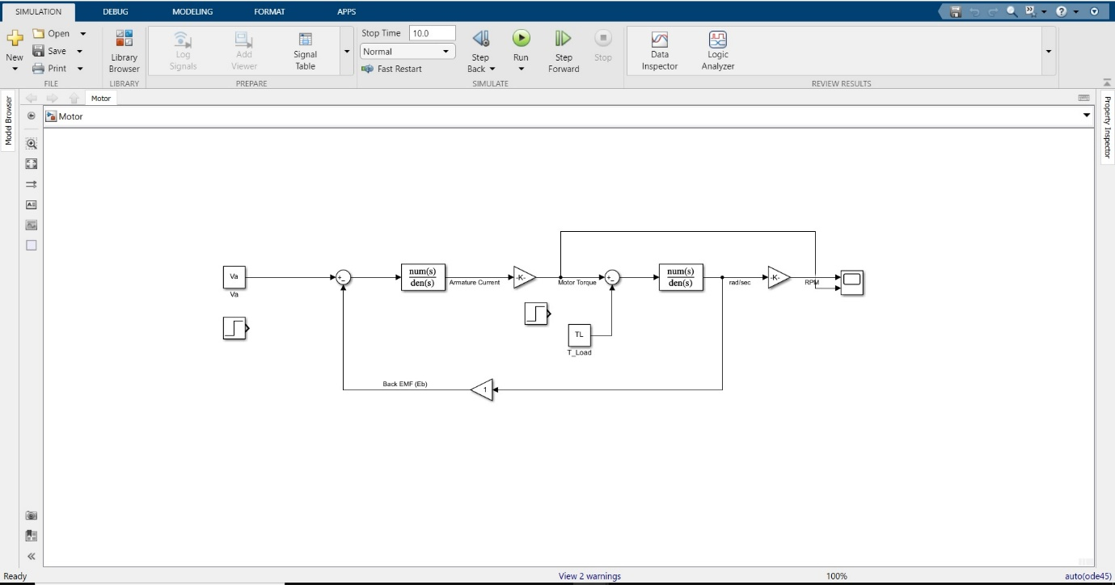

The Default Values for Motor are:

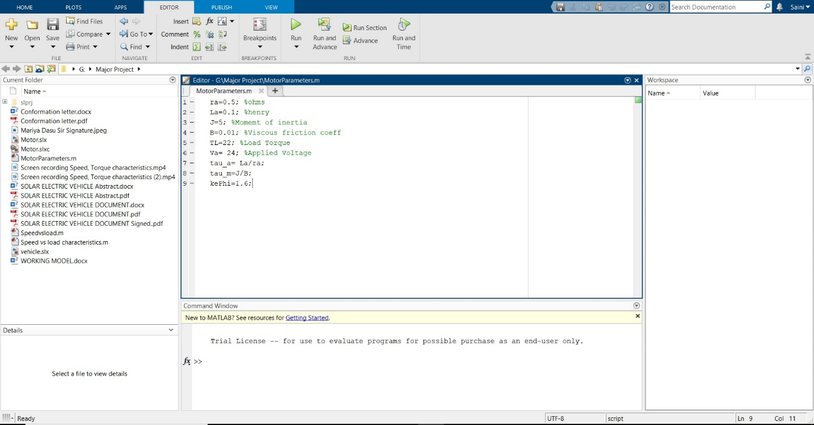

The Speed and Load characteristics of motor looks like:

